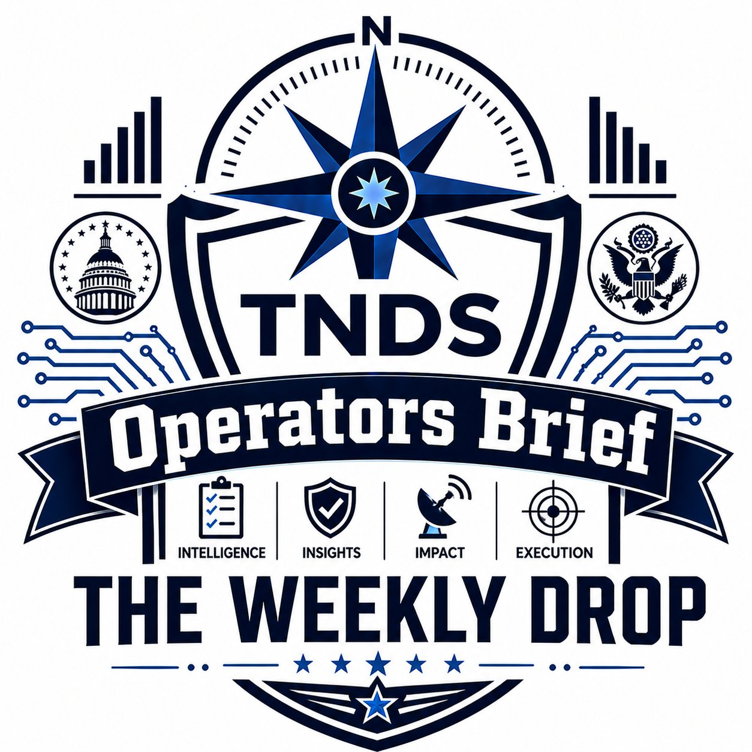
OPERATORS BRIEF
The Weekly Drop
Issue #001 · April 27, 2026 · Real Intel · Real Impact · Mission Always
IN THIS ISSUE ▸ Direction Drop · ▸ Command Drop · ▸ Field Build · ▸ Signal Check · ▸ Tool of the Week · ▸ Free Drop
Welcome to the first drop.
If you're getting this, you're on it because we've worked together, talked shop, served together, or you opted in somewhere along the way. Quick read on what this is:
Every week, you'll get one email. Six sections, 5-10-minute read, written for the operator running a real business. Topics: AI and ops in the field, lessons from running broken systems, what we're building at TNDS, and what's actually working out there.
If it's useful, stay. If it's not, reply unsubscribe and no hard feelings , I respect your inbox.
-Jacob

▸ DIRECTION DROP
Where we're pointing this week , and what we're building.
This week's heading
Communication breakdowns inside small operations , the invisible kind that don't show up on a P&L but quietly cost you customers, employees, and weekends.
Most owners don't see this problem until the person holding it together quits. Then everything they were silently fixing becomes visible , and broken. The fix isn't software. It starts with knowing who's doing that work for you.
Bearing: find the bridge before it collapses.
What TNDS is building right now
Fleet Compliance Sentinel (FCS) , our DOT/FMCSA compliance SaaS , is in test prep right now. Built for fleet operators who are tired of paperwork eating their week. If you run a fleet of any size, hit reply and ask about beta access. We're picking the first few testers carefully , looking for honest feedback, not yes-men.
CommandStack , our multi-tenant business AI operating system , is in month one of a three-month parallel build. Industry modules layered on top of a shared platform that automates simple workflows and provides business owners immediate clarity on whats going good and what’s not, then your new business assistant who was trained on you business knowledge and knows all your SOP’s and worksites and how you operate, provides recommendations the assistant can execute after staff reviews or a staff member can execute after reviewing. If it is a new issue the assistant will create a new SOP for review then when review is complete and approved email all involved employees a copy. More on this in coming issues as it gets closer to live but more info is at www.pipelinepunks.com and if you want access to the full demo drop your email in and get after it.
▸ COMMAND DROP , The Bridger Problem
Why your best people get burned out, and what to do about it.
There's someone in your shop right now who is silently holding the place together.
They're the one who notices when dispatch and accounting are about to step on each other. They're the one your foreman calls when the office sends a confusing instruction. They're the one who, in the middle of their own job, takes ten minutes to walk over to someone else's desk and translate.
You may not know who they are by name. But every business with more than five people has them. And when they leave , and they will leave, eventually , you'll find out the hard way exactly how much work they were quietly doing.
What HBR called them
Harvard Business Review ran a piece recently on what they call "Bridgers" , the people inside an organization who close the gap between departments. They speak both languages. They translate. They get marketing and operations to actually understand what the other one needs. Without them, work falls in the cracks. With them, things ship.
If you've run a business with more than five people, you already know who your Bridger is. Usually one or two folks. Often not the highest-paid. Sometimes not even officially in a leadership role. But pull them out of the building for a week and watch what happens , the wheels start coming off.

What a Bridger looks like in a small ops business
Take a six-truck plumbing outfit. The owner runs the business, the office manager handles books and scheduling, the foreman runs the crews. On paper, three roles, clean handoffs.
In reality? It's the office manager's daughter , working part-time front desk for the summer , who knows that the foreman doesn't read email but checks his texts every twenty minutes. So when the office gets an urgent customer call, she texts the foreman directly instead of "sending it through proper channels." That ten-second decision saves the company a customer about twice a week.
She's the Bridger. And the day she goes back to school, suddenly nobody on the crew is getting urgent updates and the office manager can't figure out why customer complaints just spiked.
Here's what HBR didn't say
Being the Bridger wears a person down. It's an invisible job. Nobody writes "closed the communication gap between dispatch and accounting" on a performance review, but the person doing it is doing two jobs , their own work, plus the translation work for everyone else. Over time, that grinds. They burn out, they leave, or they go quiet , and the organization doesn't realize what it lost until it's gone.
If you're running a small to mid-size operation and you've got a Bridger, three things to do this week:
- Name what they do, out loud, in front of other people. Not a title change , a recognition. "Sarah, the reason this Tuesday meeting actually works is because you spent twenty minutes Monday afternoon making sure Bob and the dispatch crew were on the same page. Thank you."
- Build a backup. Bridgers fail when there's only one of them. Pair them with someone who's learning the role , even informally. Cross-pollinate the lingo. Write down the unwritten stuff.
- Watch their workload. If your Bridger is also running their own department AND covering everyone else's communication, you're a few months from losing them. Take something off the plate.
The hard truth: most owners don't fix this until they lose someone. By then it's already cost them , turnover, training time, lost customers, the months of awkward where the team rebuilds the lost translation layer from scratch. The cheap fix is to do it now, while the bridge is still standing.

▸ BLUE COLLAR AI , Where this gets practical
Most AI tools assume the org already has clean data, defined processes, and clear handoffs between departments. Real businesses don't. The gap your Bridger is filling , that's the same gap an AI tool needs to span before it works at all.
Translation: if you're rolling out an AI tool and it's failing, the problem isn't the AI. It's that the human translation layer isn't documented anywhere. Fix the documentation, then the AI starts to work. Skip the documentation, and you're paying for software that can't see what your Bridger sees.

▸ FIELD BUILD
Real work. Real before-and-after. Real outcomes.
This week: Job tracking, paper to phone
Small field-service operation, six trucks, owner-run. The job board was a paper clipboard on a hook in the office. Crew called in updates from the field. Someone in the office wrote them on the clipboard. End of day, the owner asked "where are we on the Henderson job?" and got three different answers from three different people.
We built them a Sheets + AppSheet job tracker in two days. Crew updates status from their phones. Office sees it live. Owner pulls the dashboard on his way home and knows exactly where every truck stood at 5pm.
Before / After
BEFORE | AFTER
Paper clipboard, one copy, one location | Live mobile app, every crew member sees it
Status updates by phone call or text | Status updates with one tap from the truck
End-of-day reconciliation took 45 min | Reconciliation gone , data's already clean
Owner asked "where are we?" 6× per day | Owner checks dashboard once, knows everything
Three different answers to the same question | One source of truth

What changed: the owner got about 5 hours back per week. The crew stopped getting frustrated calls during their actual work. The office stopped being the bottleneck. Total build time: ~14 hours. No new software contracts, no subscription bills , they were already paying for Google Workspace.
Why this is in the newsletter: if you've got a clipboard, a whiteboard, or a group text doing the job a system should be doing , that's a Field Build candidate. Reply and tell me what yours is. I'll write next week's newsletter around it.
▸ SIGNAL CHECK
Three things from this week worth your attention. Filtered for relevance to operators, not headlines.
1. The AI model wars matter less than you think
The AI model wars matter a whole lot less than people think.
Every week there’s a new “breakthrough” model getting hyped online. Most of them won’t change a damn thing about what you do Monday morning.
What will change your business is when AI gets cheap enough, reliable enough, and simple enough to work inside the tools you already use — your fleet system, inventory, dispatch board, scheduling, and operations. That shift is already happening fast.
The real wins are not coming from flashy demos. They’re coming from companies saving time, tightening operations, cutting mistakes, and making better decisions without adding more people.
Ignore the hype if you want, but don’t ignore the direction things are moving. The companies learning this stuff now are going to outwork, out-respond, and out-scale the ones waiting until it’s “safe” to start.
2. The compliance window is closing
If you run a fleet, handle DOT or FMCSA paperwork, or do any work for federal agencies, the audit posture in 2026 is harder than it was in 2024. CMMC 2.0 enforcement is real. SOC 2 is no longer a "big company thing." If a customer asks for it and you don't have it, you lose the contract. Cheaper to start the work now than scramble later.
3. Small shops are using AI better than the enterprise
The shops getting real lift from AI right now are 5-to-50-person operations where the owner can make a decision in a meeting and see results the same week. Enterprise AI rollouts are stuck in pilot purgatory. Speed beats budget , and you have the speed.
▸ TOOL OF THE WEEK
Only tools we actually use, every day, on real work. No affiliate links, no "this looks cool," no Twitter trends.
This week: Google Sheets + AppSheet & Microsoft Excel + Power Automate
Yeah — the boring ones.
The tools nobody writes about because they’re not flashy and there’s no billion-dollar funding round behind them.
Here’s why we’re starting there:
90% of the small businesses we work with already have Google Workspace or Microsoft Business licenses. They’re already paying for the tools. Most just aren’t using them past email and spreadsheets.
But the combination of Sheets or Excel — where your data already lives — plus AppSheet or Power Automate is one of the most underrated automation setups for businesses with 5 to 50 employees.
You can turn a spreadsheet into a real mobile app, automate job updates, track inventory, manage inspections, dispatch crews, collect field photos, trigger alerts, and clean up the daily chaos without hiring a developer or buying another expensive platform.
This isn’t about “AI replacing people.”
It’s about helping good people stop wasting half their day chasing paperwork, texts, and missing information.

What you can build with it in a weekend:
- A job tracking system your crew updates from their phones, with photos and signatures.
- A daily DOT inspection log that auto-emails you issues.
- An asset tracker that knows when something's due for service.
- A simple dispatch board that updates in real time across your team.
None of this is fancy. All of it works. We've installed versions of every one of these for clients. The pattern is always the same: replace a clipboard, a paper form, or a hand-typed text message , and pull six hours a week out of someone's job.
Cost: $0 to start (free tier). Most small ops never outgrow it.
Trap to avoid: people overcomplicate it on day one. Build the simplest possible version first. Add features only when someone actually asks for them.
▸ FREE DROP , This Week's Download
▸ THE BRIDGER AUDIT
A one-page worksheet to map who your Bridgers are, where the communication gaps actually live, and what's at risk if you lose them. Built for owners running 5-to-50 person operations.
Five questions, ten minutes, hand it to your leadership team. If you can't answer all five without thinking, you've got work to do.
👉 Reply to this email with the word BRIDGER and I'll send it back to you within 24 hours. No form, no pop-up, no tracking. Just an email back.
That's the drop.
If something here was useful, forward it to one person who'd benefit. If something missed the mark, hit reply and tell me. Both make the next issue better.
See you next Monday. , Jacob
Operators Brief is published by True North Data Strategies LLC
Colorado Springs, CO · SBA-Certified SDVOSB/VOSB
jacob@truenorthstrategyops.com · 719-204-6365
Forwarded to you? Subscribe at pipelinepunks.com. Done with us? Unsubscribe link goes here.
Real Intel · Real Impact · Mission Always.

